West Hull Ladies
RRC

March Newsletter

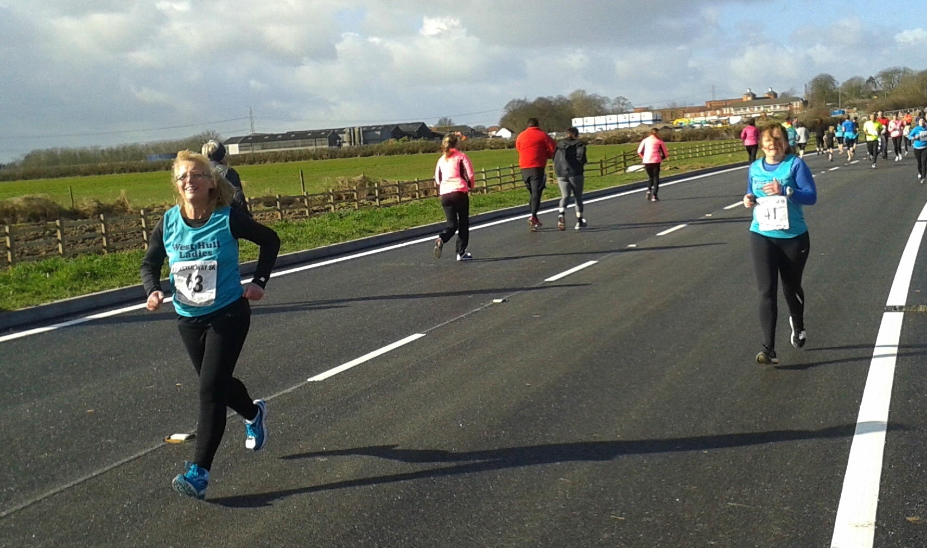
Beverley 5k

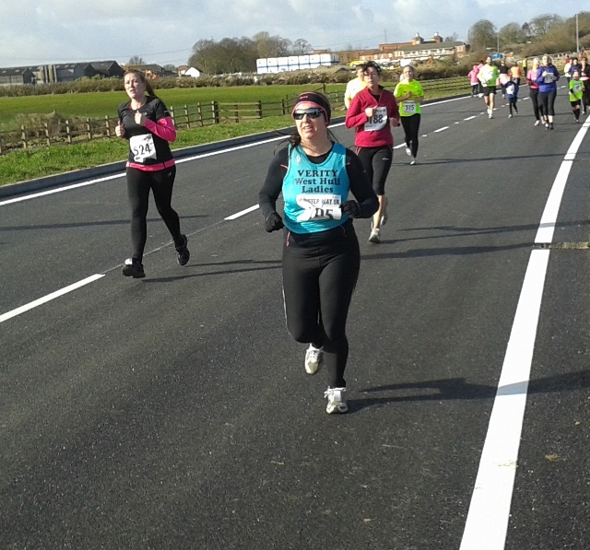

Minutes from the AGM 2015
Monday 2nd March 2015

Present - Jill, Linda, Karen, Sandra, Zoe, Amanda, Maria, Liz, Rachael A, Liz D, Jan D, Liz, Lynn, Sarah W, Anna, Jermaine, Jane, Rachael W, Kate T, Kristine, Suzanne

- Minutes of previous AGM held 21st March 2014 agreed
- Jill (Chair) delivered her reporting detailing how the Club was thriving mentioning specific events such as 0-5k, Great British Relay and Thunder Run. She went onto say how we had the support of other running Clubs in the area. Thanks were given to all the work carried out by members of the Committee and for all the Lady members who made running with the club such an enjoyable event.
- Linda (Treasurer) gave a report on the clubs finances and confirmed the accounts had been audited. At the present time the account held £4102.06 but money for kit recently purchased was still to be paid.
- Karen (Members Secretary) gave a report detailing the fact that membership now stood at 67 plus 2-second claim members. As a Club we were eligible for 2 London Marathon places.
- An amendment as to who was eligible to apply for London Marathon Club Places was accepted.
- See http://westhullladies.org.uk/londonmarathon.htm
- The election of Committee Members then took place with the following being elected

Chair Jill Jameson
Secretary Sandra Holdsworth
Member Sec Karen Scott
Treasurer Linda Dodsworth
Liaison Officer Annette Pearson
Lead Coach Amanda Dean
Kit Officer Maria Diaz
Newsletter *Anna Shepherdson
Racing Officer Zoe Jameson
Park Run Liaison Andrea Thomson
10k Series Liz Draper
Press Officer Radio Linda Dodsworth
Press Officer Newspaper Liz Draper
Events/Social Jan, Rachael, Anna, Liz

Snake Lane 10 - Linda 22nd February
I can’t quite believe just how many ladies entered this race, there were 16 of us altogether. This is one race I was adamant I wouldn’t do again after last year. That’s because it was so windy that I think I nearly got blown over a few times and battling against head wind for five miles was no fun. But I got swept along when I saw the entries had opened and ladies were putting on FB that they had entered!

The morning arrived and this race doesn’t start until 11am so that gave me time to walk the dog and when I got home get ready in peace. My breakfast had time to digest properly and I walked to the Market Place in South Cave to be picked up by Rachel W and I shared her car with Ros and Maria. It was nice to travel with the girls and talk about the race. It was a cold morning but at least it was dry and although it promised rain that wasn’t due until dinner time. It wasn’t windy either so that was a bonus.

When we arrived we met up with the other ladies and joined the queues for the loos! Before we knew it, it was time to walk to the start which is quite a walk from the rugby club, or so it seemed. Finally we were off, now this is where I always make the mistake of going off too fast but still it’s only 10 miles, I do this in training so it’s a doddle! Yeah right. Debbie past me at the first mile which was to be expected (she’s so fast), and I got myself into a steady pace which I was so enjoying, there are no hills to speak of in this race until nearer the end. The first five miles went by quite quickly and then we turned a bend and the wind hit me, boy I’d been quite warm up till then and was wondering if I’d too many clothes on (again I always make this mistake), but no that wind was absolutely freezing and now I was wondering why I hadn’t put on my hat too. My face was feeling numb the wind was so cold.

I battled on, the wind did not abate at all, now I know why I didn’t like this race! I was wishing I was at home in the warm. Now I was counting the miles off as we past the mile marker boards and then as we approached mile 8 Rachel A past me (another speedy lady) I did try and keep up with her but no, away she went. Finally mile 9 and then I heard this voice, oh yes Sandra it was you, telling me about my shoulders, I had to relax into it, I was obviously tiring now and she could see it, bet I looked like an old woman struggling! (Well I am in all fairness)! Anyway the lovely Sandra ran with me that last mile keeping me going telling me when there was only 800m to go then 600m then 400m then the last 200m and then she asked me to sprint to the finish, can you believe it, sprint she must be joking so I let her go in front of me and I tried chasing her in. I did it, finally the race was over. Thank you Sandra you really did help me. My time was 1:25:46 and last year it was 1:29:32 so a PB for me, I was so pleased. Love WHL without you all I couldn’t improve like I have this last two years.

We received a lovely hand thrown mug and a Snickers bar plus a bottle of water, so a great mornings work.

Sandra and I then jogged up the road shouting as many WHL in that we could find until we were frozen to death then we just had to go and put some clothes on and get warm. By now it was also raining/sleeting so I was glad to get back into the warm car.

A great race and would I do it again? We’ll see when 2016 arrives!

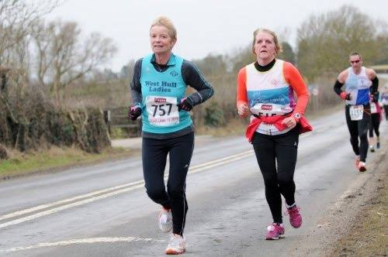

6 Weeks to a 5K - Linda

I love the 0-5k series which I’ve helped with for the last two years. This year I managed to get onto the radio and advertise it a number of times (Radio Humberside must be so fed up of me nagging)!

We had a lovely group of ladies join at the beginning and I’m still not sure how many completed the course but the ones that did I would just like to say welcome to our club and well done. The hardest part is now over, by that I mean training three nights a week in the wind, rain, sleet, ice you have all battled through and seemed to enjoy the training. It gets easier now because it gets warmer well I know that still seems quite a way off but the nights are staying lighter and training in daylight is so much better.

I was proud to be able to take part in your first Park Run on February 14th, there were so many photos of everyone and you all had huge smiles on your faces. So please give yourselves a well-deserved pat on the back. I know you’ll continue doing park runs and will improve over the coming weeks.

Some of you have entered your first 10k race, Beverley, which is a lovely route and I know you’ll be ready to take part in that. Lots of training ahead of you but look how far you’ve already come so building up to a 10k will come naturally to you all. Well done everyone.

Newton’s Fraction Half Marathon – Linda 15th March

I only entered this race because I didn’t get in on time for the Gainsborough 10k. I hadn’t even heard of Newton’s Fraction until Rich Harrison (City of Hull) mentioned it to me and said there were spaces in his car. Why not, so I entered.

Finally it came round, luckily I was feeling better having had a bit of a head cold during the week following Golden Fleece. Met up with the lads at Humber Bridge car park and we were off. Felt a bit odd being the only girl but they soon made me feel comfortable chatting away (well we are talking Rich Harrison here)!

It’s quite a long journey don’t think I’ve travelled quite so far to run a race before (1.5hrs), I know some of you travel miles! We were early so we made our way to the Grantham Football Club which is also a running track and a very nice one too. Had a cup of tea and there weren’t any queues for the loos. It was cold outside so it was lovely to have somewhere to wait and at 10.25 we made our way outside onto the running track and before I knew it we were off.

I started off steady so trying not to go off too fast to conserve my energy for later on! The first mile over and then we went down onto a canal tow path, I’m sure we ran alongside the canal for around 5 miles, it was lovely no traffic. Then we joined the road again and around half a mile later we approached the first hill. This was quite steep but not so long and I managed that quite well only walking for a little while, I thought this was the steep hill everyone was going on about so I was very pleased it was over then there were lots of downs and straights, a lovely route through countryside. Very well marshalled and lots of photographers around, or so it seemed. I was thoroughly enjoying the run and the conditions although it was cold there were no strong winds.

At mile 10 there was a water station and ladies handing out jelly babies, lovely, they said just up the hill then you’re nearly home. Hill, I thought we’d done the hill. Well, oh boy, what a hill. Anyone that knows the hill from my house towards Sandra’s at Little Weighton (Beverley Road, South Cave) and how it goes up and up through the woods, well this road was just like this but it continued for a mile! Everyone was walking and then giving a feeble little jog, me included. It took me 11.03 mins to get to the top of this hill and when you got to the top it didn’t go down like I expected it kind of went straightish we ran for nearly another mile before there was a slight downhill section which led into the stadium for the finish. As you approached the stadium you had to run 400 metres round the track to the finish funnel. That 400 metres felt like a long way. Finally the finish to be cheered in by City of Hull lads.

We got a medal, T.Shirt, banana and fab goodie bag at the finish. My time was 1:59:04 not my fastest half but I was well pleased with the result considering the hills. Oh and I was second lady in my age category the first lady did it in 1:52 so I have some hard training to get under my belt in preparation for next year.

A great event, well marshalled, only 500 competitors allowed so quite low key, very friendly, fab facilities.

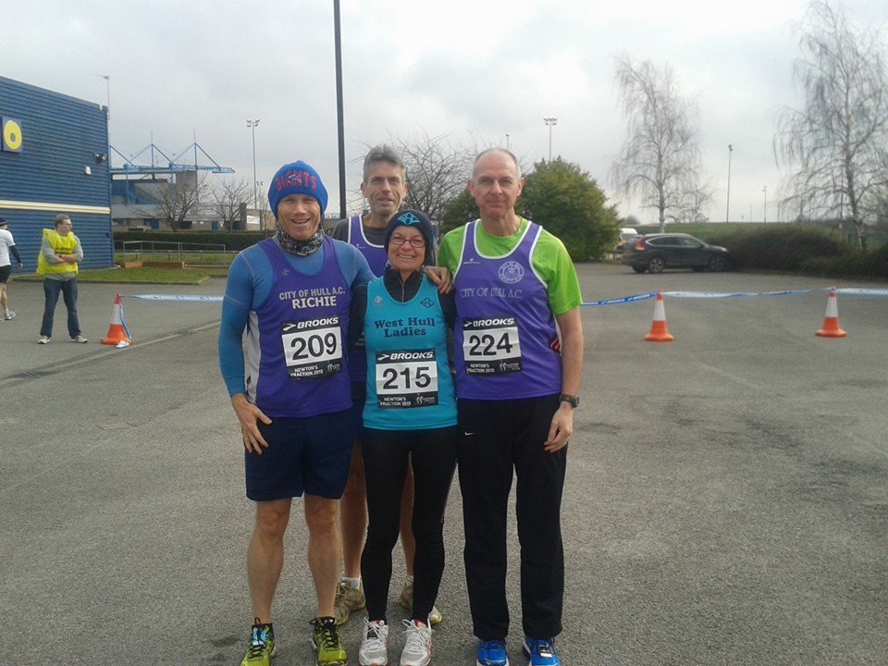

2015 RACE DIARY

Date/Time | Event
April 2015

 | 3rd/10:00 | Bridlington Easter 5 Mile Dash
 | 26th/10:00 | Virgin Money London Marathon
May2015 | 3rd/09:00 | North Lincolnshire Half Marathon
 | 10th/11:15 | Beverley 10K
 | 10th/09:30 | Jane Tomlinson Leeds Half Marathon

Please remember to double check dates, times and entry fees Keep checking the website for new races and updates:

NOTE: Club Vests must be worn at any races you enter
under the West Hull Ladies running club name.

West Hull Ladies Road Running Club
Kit Order Form

FORENAME ___________________________________
SURNAME ___________________________________

ORDER - tick what you require and circle your size Price
- VEST SIZE 10 12 14 16 £16.00
- LONG SLEEVED SIZE 10 12 14 16 £18.50

- HOODIE SIZE XS S M L £20
- HOODIE with ZIP SIZE XS S M L £20
Note on size, M is approximately size 14

- BEANIE HAT £6.50
- PINLESS WHL NUMBER FASTENERS (set of 4) £3.00

DATE Ordered _______________
AMOUNT PAID _______________
Please transfer payments online with your name and marked as ‘Kit to:
Account: 63762742 Sort Code: 20 43 49

Or cheque payable to ‘West Hull Ladies RRC’, and write your name and ‘Kit’ on the back and give to Club Treasurer Linda Dodsworth, 110 The Stray, South Cave, E Yorkshire. HU15 2AL

Sign on receipt of goods _________________________________
DATE _______________

Please complete this form and email to diazmaria@btinternet.com
Thanks.
Maria Kit Officer

